Supplementary data
Table S1: Characteristics of the “GP appropriate” patients attending the ED at Alder Hey with standardised differences
Variable | GP hours ED Total  2821 (54%) 2402 (46%) 5223 | Standardised difference
Gender  Female  Male | 1380 (48.9%) 1170 (48.7%) 2550 (48.8%)  1441 (51.1%) 1232 (51.3%) 2673 (51.2%) | 0.004 (-3.94, 3.94)  -0.004 (-3.80, 3.80)
Age categorical  < 1 yr  1-5 yrs  5-10 yrs  >10 yrs | 761 (27%) 574 (23.9%) 1335 (25.6%)  1244 (44.1%) 1006 (41.9%) 2250 (43.1%)  479 (17.0%) 481 (20.0%) 960 (18.4%)  337 (11.9%) 341 (14.2%) 678 (13.0%) | 0.0712 (-4.65, 4.79)  0.0444 (4.10, 4.14)  -0.0773 (-4.99, 4.53)  -0.0683 (-5.14, 5.00)
Deprivation quintiles  1  2  3  4  5 | 67 (2.4%) 76 (3.2%) 143 (2.7%)  144 (5.1%) 129 (5.4%) 273 (5.2%)  290 (10.3%) 238 (9.9%) 528 (10.1%)  386 (13.7%) 308 (12.8%) 694 (13.3%)  1933 (68.5%) 1647 (68.6%) 3180 (68.5%) | -0.0485 (-5.47, 5.37)  -0.0135 (-5.63, 5.61)  -0.0133 (-5.15, 5.18)  0.0265 (-5.07, 5.12)  -0.0022 (-3.05, 3.05)

Table S2: Discharge status by PP analysis
Discharge | GP hours GP to ED ED Total
Own GP follow-up  Discharged  Admitted  Outpatient services  A&E services  Community service  Dentist  Left before being seen | 1132 (49.2%) 15 (11.4%) 288 (16.8%) 1435 (34.6%)  1115 (48.4%) 53 (70.0%) 1076 (62.7%) 2261 (54.5%)  6 (0.3%) 35 (26.5%) 138 (6.0%) 179 (4.3%)  5 (0.2%) 8 (6.1%) 85 (5.0%) 98 (2.4%)  3 (0.1%) 1 (0.8%) 15 (0.9%) 14 (0.5%)  1 (0.1%) 2 (1.5%) 4 (0.2%) 7 (0.2%)  1 (0.8%) 1 (0.1%) 2 (0.1%)  40 (1.7%) 108 (6.3%) 148 (4.3%)

Table S3: Outcomes by PP analysis
Outcome | GP hours ED Odds ratio
Admitted  Antibiotics  Wait exceeded 4hrs  Left before seen | 41 (1.7%) 138 (8.0%) 0.20 (0.14, 0.28)  647 (27.0%) 464 (17.5%) 1.74 (1.48, 2.03)  40 (1.6%) 108 (6.3%) 0.25 (0.17, 0.36)  36 (1.5%) 85 (5.0%) 0.29 (0.19, 0.43)

Table S4: Sensitivity analysis of patients seen between 10:00 – 18:00 n=2781 by ITT analysis
Outcome | GP hours ED Odds ratio
Admitted  Antibiotics  Wait exceeded 4hrs  Left before seen | 30 (2.1%) 65 (4.8%) 0.44 (0.28, 0.67)  390 (28.2%) 298 (12.7%) 1.33 (1.12, 1.59)  37 (2.6%) 54 (4.0%) 0.45 (0.33, 0.61)  31 (2.2%) 49 (3.6%) 0.65 (0.43, 0.99)

Table S5: Sensitivity analysis of patients seen between 10:00 – 18:00 n=2781 by PP analysis
Outcome | GP hours ED Odds ratio
Admitted  Antibiotics  Wait exceeded 4hrs  Left before seen | 26 (2.0%) 47 (6.9%) 0.27 (0.17, 0.44)  377 (28.8%) 116 (17.6%) 1.89 (1.50, 2.39)  29 (2.2%) 14 (2.0%) 1.07 (0.56, 2.03)  28 (2.1%) 26 (3.8%) 0.54 (0.32, 0.93)

Table S6: Sensitivity analysis of patients seen between 10:00 – 18:00 n=2781 by ITT analysis
excluding patients with diagnosis of “other “

Outcome | GP hours ED Odds ratio
Admitted  Antibiotics  Wait exceeded 4hrs  Left before seen | 48 (1.8%) 60 (2.8%) 0.64 (0.44, 0.94)  690 (26.4%) 435 (21.0%) 1.75 (1.17, 1.54)  64 (2.4%) 116 (5.4%) 0.43 (0.32, 0.59)  72 (2.7%) 103 (4.8%) 0.55 (0.41, 0.75)

Table S7: Sensitivity analysis of children stratified by age
Outcome | <=5 >5 Odds ratio
Admitted  Antibiotics  Wait exceeded 4hrs  Left before seen | 152 (4.2%) 66 (4.1%) 1.04 (0.77, 1.40)  827 (24.0%) 350 (22.0%) 1.09 (0.95, 1.26)  130 (3.6%) 58 (3.6%) 1.01 (0.74, 1.38)  161 (4.5%) 64 (4.0%) 1.14 (0.85, 1.53)

Table S8: Sensitivity analysis with data split by first and second half of the month
Outcome | GP 1st half GP 2nd half Odds ratio
Admitted  Antibiotics  Wait exceeded 4hrs  Left before seen | 28 (2.0%) 34 (2.4%) 1.18 (0.71, 1.96)  362 (26.8%) 351 (25.3%) 0.93 (0.78, 1.10)  33 (2.4%) 33 (2.3%) 0.97 (0.59, 1.58)  42 (3.0%) 46 (3.2%) 1.06 (0.70, 1.63)

Figure S1: Antibiotics prescribed to “GP appropriate” patients according to GP group and ED group by percentage of prescriptions
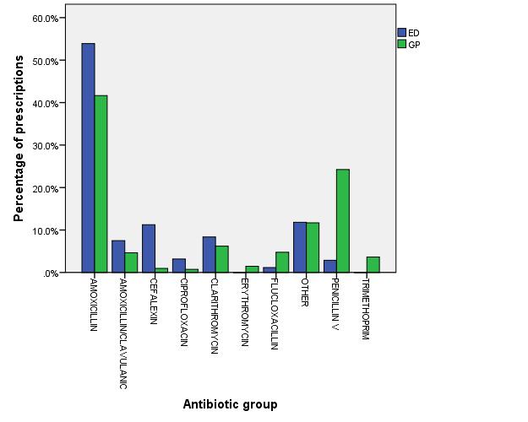

Appendix S9: Assessing how big the unobserved confounding would need to be to change the estimated treatment effects significantly.
The odds for admission comparing children seen in non-GP hours compared to GP hours was 1/0.32 = 3.125 95%CI 2.27 to 4.16. Following Ping 2016, we are interested in assessing if the observed OR of the exposure E on the outcome D might be completely due to the existence of a common confounder U. For a binary unmeasured confounder to completely explain away the observed OR, both the exposure–confounder OR and the confounder–outcome OR would have to be at least 3.125. Let us now assume then that both the exposure–confounder OR and the confounder–outcome OR have the magnitude 3.125. The joint bounding factor is (3.125*3.125)/(3.125 + 3.125 - 1) = 1.86. Even if we assume such a strong confounder, the point estimate of the causal OR of non-GP hours and admission must still be at least as large as 3.125/1.86 = 1.76 with confidence intervals 1.22 to 2.23. In fact, to explain away the point estimate of the observed OR of 3.125, the magnitude of OR_{EU} and OR_{UD} (if OR_{EU} = OR_{UD}) should be at least as large as 3.125 + sqrt(3.125 - 1) = 4.58. And to explain away the lower confidence limit 2.27, these two confounding risks should be at least as large as 2.27 + sqrt(2.27 - 1) = 3.4. Since these risks are relatively large, this provides some reassurance that are results are robust to unmeasured confounding.

Ref: Ping D, VanderWeele TJ. Epidemiology. Sensitivity Analysis Without Assumptions 2016 May; 27(3): 368–377.

