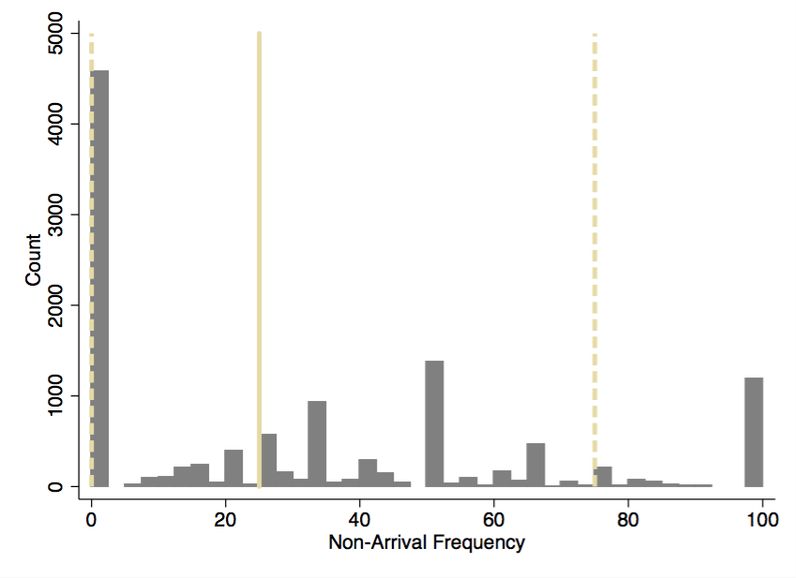
Supplemental Figure 1. Patient-Level Non-Arrival Frequency Histogram. In the cohort of 11,812 patients, the median non-arrival frequency was 25% (solid khaki line) and the 25th-75th percentile range was 0% to 50% (dashed khaki line).

Supplemental Table 1. Cross tabulation of transport time estimate classifications for bus and car at each ZIP code starting location
 | Shortest transport time by bus | Intermediate transport time by bus | Longest transport time by bus
Shortest transport time by car | 3 | 2 | 0
Intermediate transport time by car | 4 | 4 | 2
Longest transport time by car | 0 | 2 | 3

Supplemental Table 2. Multivariable model for association between clinic appointment non-arrival and car transport characteristics.
Variable | Odds Ratio | 95% CI | p-value
Age
Age < 1 year | ref
Age 1-5 years | 1.59 | 1.50 – 1.69 | < 0.01
Age 6-12 years | 1.62 | 1.51 – 1.74 | < 0.01
Age 13 years and over | 1.62 | 1.49 – 1.75 | < 0.01
Race
White | ref
Black | 1.75 | 1.59 – 1.92 | < 0.01
Asian | 0.40 | 0.28 – 0.57 | < 0.01
Other | 1.25 | 1.03 – 1.50 | 0.02
Ethnic
Non-Hispanic | ref
Hispanic | 0.62 | 0.52 – 0.74 | < 0.01
Unknown | 1.14 | 0.94 – 1.38 | 0.18
Season
Winter | ref
Spring | 0.93 | 0.88 – 0.98 | < 0.01
Summer | 0.92 | 0.87 – 0.97 | < 0.01
Fall | 0.70 | 0.66 – 0.74 | < 0.01
Appointment Type
Not Well | ref
Well | 1.56 | 1.47 – 1.64 | < 0.01
Car transit time – income
Lowest income – shortest time | ref
Lowest income – intermediate time | 1.09 | 0.96 – 1.25 | 0.20
Lowest income – longest time | 1.21 | 1.07 – 1.36 | < 0.01
Intermediate income – shortest time | 1.11 | 1.00 – 1.23 | 0.06
Intermediate income – intermediate time | 1.07 | 1.00 – 1.16 | 0.06
Intermediate income – longest time | 1.02 | 0.88 – 1.15 | 0.82
Highest income – shortest time | 0.84 | 0.70 – 0.99 | 0.049
Highest income – intermediate time | 0.92 | 0.81 – 1.04 | 0.18
Highest income – longest time | 1.01 | 0.89 – 1.14 | 0.90
Constant | 0.14 | 0.12 – 0.16 | < 0.01

Supplemental Table 3. Multivariable model for association between clinic appointment non-arrival and bus transport characteristics.
Variable | Odds Ratio | 95% CI | p-value
Age
Age < 1 year | ref
Age 1-5 years | 1.59 | 1.50 – 1.69 | < 0.01
Age 6-12 years | 1.62 | 1.51 – 1.74 | < 0.01
Age 13 years and over | 1.61 | 1.50 – 1.76 | < 0.01
Race
White | ref
Black | 1.74 | 1.58 – 1.91 | < 0.01
Asian | 0.41 | 0.28 – 0.58 | < 0.01
Other | 1.25 | 1.03 – 1.51 | 0.02
Ethnic
Non-Hispanic | ref
Hispanic | 0.62 | 0.52 – 0.74 | < 0.01
Unknown | 1.14 | 0.94 – 1.38 | 0.18
Season
Winter | ref
Spring | 0.93 | 0.88 – 0.98 | < 0.01
Summer | 0.92 | 0.87 – 0.97 | < 0.01
Fall | 0.70 | 0.66 – 0.74 | < 0.01
Appointment Type
Not Well | ref
Well | 1.56 | 1.48 – 1.64 | < 0.01
Bus transit time – income
Lowest income – shortest time | ref
Lowest income – intermediate time | 1.17 | 1.04 – 1.32 | 0.01
Lowest income – longest time | 1.55 | 1.27 – 1.85 | < 0.01
Intermediate income – shortest time | 1.19 | 1.06 – 1.34 | < 0.01
Intermediate income – intermediate time | 1.32 | 1.14 – 1.52 | < 0.01
Intermediate income – longest time | 1.13 | 0.98 – 1.31 | 0.09
Highest income – shortest time | 0.84 | 0.70 – 0.99 | 0.049
Highest income – intermediate time | 1.23 | 1.05 – 1.59 | 0.02
Highest income – longest time | 1.16 | 0.95 – 1.41 | 0.15
Bus transfer | 0.93 | 0.84 – 1.03 | 0.15
Bus walk distance
Shortest | ref
Intermediate | 0.89 | 0.81 – 0.98 | 0.02
Longest | 0.80 | 0.71 – 0.91 | < 0.01
Constant | 0.14 | 0.12 – 0.16 | < 0.01

Supplemental Table 4. Sensitivity analysis multivariable model for association between clinic appointment non-arrival and bus transport characteristics, without bus transfer or walk distance.
Variable | Odds Ratio | 95% CI | p-value
Age
Age < 1 year | ref
Age 1-5 years | 1.59 | 1.50 – 1.69 | < 0.01
Age 6-12 years | 1.62 | 1.51 – 1.73 | < 0.01
Age 13 years and over | 1.61 | 1.49 – 1.75 | < 0.01
Race
White | ref
Black | 1.76 | 1.60 – 1.93 | < 0.01
Asian | 0.40 | 0.28 – 0.58 | < 0.01
Other | 1.24 | 1.03 – 1.50 | 0.02
Ethnic
Non-Hispanic | ref
Hispanic | 0.60 | 0.51 – 0.72 | < 0.01
Unknown | 1.14 | 0.95 – 1.38 | 0.16
Season
Winter | ref
Spring | 0.93 | 0.88 – 0.98 | < 0.01
Summer | 0.92 | 0.87 – 0.97 | < 0.01
Fall | 0.70 | 0.66 – 0.74 | < 0.01
Visit Type
Other | ref
Well | 1.56 | 1.47 – 1.64 | < 0.01
Bus transit time – income
Lowest income – shortest time | ref
Lowest income – intermediate time | 1.12 | 1.00 – 1.26 | 0.05
Lowest income – longest time | 1.23 | 1.07 – 1.41 | < 0.01
Intermediate income – shortest time | 1.08 | 0.99 – 1.17 | 0.08
Intermediate income – intermediate time | 1.11 | 1.02 – 1.21 | 0.02
Intermediate income – longest time | 0.99 | 0.89 – 1.10 | 0.86
Highest income – shortest time | 0.84 | 0.70 – 0.99 | 0.049
Highest income – intermediate time | 1.03 | 0.89 – 1.18 | 0.71
Highest income – longest time | 0.92 | 0.82 – 1.03 | 0.15
Constant | 0.14 | 0.12 – 0.16 | < 0.01

Supplemental Table 5. Odds ratios not arriving to scheduled clinic appointment by ZIP code income and direct drive time.
Group | Odds ratio | 95% Confidence Interval | p-value
Lowest income ZIP codes
Shortest drive time | ref
Intermediate drive time | 1.09 | 0.96 – 1.25 | 0.20
Longest drive time | 1.21 | 1.07 – 1.36 | < 0.01
Intermediate income ZIP codes
Shortest drive time | ref
Intermediate drive time | 1.08 | 1.00 – 1.17 | 0.06
Longest drive time | 1.02 | 0.89 – 1.16 | 0.82
Highest income ZIP codes
Shortest drive time | ref
Intermediate drive time | 0.92 | 0.81 – 1.04 | 0.18
Longest drive time | 1.01 | 0.89 – 1.14 | 0.90

Supplemental Table 6. Odds ratios not arriving to scheduled clinic appointment by ZIP code income and bus transit time.
Group | Odds ratio | 95% Confidence Interval | p-value
Lowest income ZIP codes
Shortest transit time | Ref
Intermediate transit time | 1.17 | 1.04 – 1.32 | 0.01
Longest transit time | 1.54 | 1.27 – 1.85 | < 0.01
Intermediate income ZIP codes
Shortest transit time | Ref
Intermediate transit time | 1.32 | 1.14 – 1.52 | < 0.01
Longest transit time | 1.13 | 0.98 – 1.31 | 0.09
Highest income ZIP codes
Shortest transit time | Ref
Intermediate transit time | 1.29 | 1.05 – 1.59 | 0.02
Longest transit time | 1.16 | 0.95 – 1.41 | 0.15

