Parameter | Greater London compared with the rest of England (excluding Manchester) |  | HASUs compared with the rest of England (excluding Manchester)
 | Estimate (SE) | p-value | Estimate (SE) | p-value
 | Seven-day in-hospital mortality
Intercept | 0.044  (0.010) | <.0001 | 0.053  (0.012) | <.0001
Admission time (quarter) | -0.002  (0.001) | 0.0626 | -0.003  (0.001) | 0.0043
Area | -0.006  (0.012) | 0.6134 | -0.002  (0.015) | 0.8917
Policy | 0.008  (0.0152) | 0.6042 | 0.024  (0.019) | 0.1959
Area*Policy | -0.007  (0.015) | 0.6472 | -0.017  (0.018) | 0.3567
 | Thirty-day in-hospital mortality
Intercept | 0.021  (0.005) | <.0001 | 0.022  (0.006) | 0.0003
Admission time (quarter) | -0.001  (0.0004) | 0.0584 | -0.001  (0.001) | 0.0383
Area | -0.002  (0.007) | 0.7604 | -0.007  (0.008) | 0.3528
Policy | 0.008  (0.008) | 0.3222 | 0.012  (0.010) | 0.2200
Area*Policy | 0.0003  (0.008) | 0.9675 | 0.003  (0.009) | 0.7856
Estimate unit is death per admission
Supplement table 1. Results of the regression analysis assessing the effect of time, area and policy on the difference between weekend/weekday for seven and thirty-day in-hospital mortality (SE- coefficient standard errors)

Supplement figure 1. The difference of adjusted in-hospital mortality rates between weekend/weekday by quarter (vertical grey line presents the time when stroke services were reorganised)
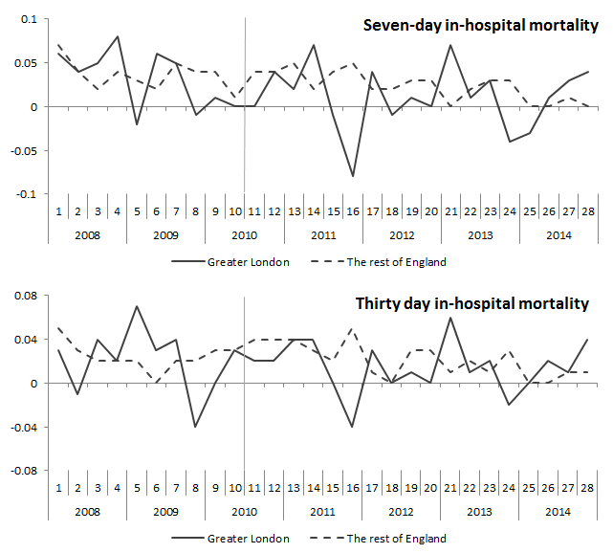

Supplement figure 2. The change of the number of emergency hospital admissions in hyper acute stroke units (HASUs) as a percentage of all hospital admissions in Greater London by quarter
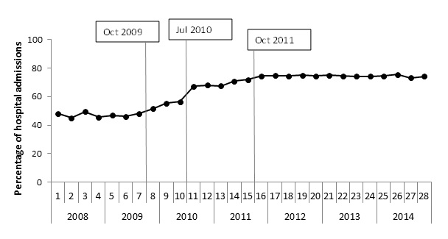

Supplement table 2. Results of the regression analysis assessing the effect of time, area and policy on the difference between weekend/weekday for seven and thirty-day in-hospital mortality (SE- coefficient standard errors) (assuming that the introduction of
centralisation started in Oct 2009)
Parameter | Greater London compared with the rest of England |  | HASUs compared with the rest of England
 | Estimate (SE) | p-value | Estimate (SE) | p-value
 | Seven-day in-hospital mortality
Intercept | 0.045  (0.005) | <0.001 | 0.043  (0.010) | <0.001
Admission time (quarter) | -0.002  (0.0004) | <0.001 | -0.002  (0.0004) | <0.001
Area | 0.007  (0.015) | 0.617 | 0.022  (0.021) | 0.306
Policy | 0.008  (0.008) | 0.328 | 0.010  (0.009) | 0.231
Area*Policy | -0.022  (0.017) | 0.178 | -0.042  (0.024) | 0.077
 | Thirty-day in-hospital mortality
Intercept | 0.012  (0.002) | <0.001 | 0.013  (0.002) | <0.001
Admission time (quarter) | -0.001  (0.0002) | 0.001 | -0.001  (0.0002) | <0.001
Area | 0.007  (0.006) | 0.235 | 0.007  (0.009) | 0.423
Policy | 0.009  (0.004) | 0.139 | 0.012  (0.004) | 0.072
Area*Policy | -0.010  (0.007) | 0.172 | -0.015  (0.010) | 0.146
Estimate unit is death per admission

Supplement table 3. Results of the regression analysis assessing the effect of time, area and policy on the difference between weekend/weekday for seven and thirty-day in-hospital mortality (SE- coefficient standard errors) (assuming that the introduction of
centralisation started in Oct 2011)

Parameter | Greater London compared with the rest of England |  | HASUs compared with the rest of England
 | Estimate (SE) | p-value | Estimate (SE) | p-value
 | Seven-day in-hospital mortality
Intercept | 0.048  (0.006) | <0.001 | 0.047  (0.006) | <0.001
Admission time (quarter) | -0.001  (0.001) | 0.018 | -0.001  (0.001) | 0.025
Area | -0.008  (0.010) | 0.452 | -0.005  (0.014) | 0.728
Policy | 0.001  (0.001) | 0.938 | 0.004  (0.010) | 0.689
Area*Policy | -0.005  (0.014) | 0.734 | -0.014  (0.018) | 0.447
 | Thirty-day in-hospital mortality
Intercept | 0.014  (0.003) | <0.001 | 0.016  (0.003) | <0.001
Admission time (quarter) | -0.0003  (0.0003) | 0.24 | -0.0004  (0.0003) | 0.188
Area | 0.001  (0.004) | 0.760 | -0.001  (0.006) | 0.859
Policy | 0.001  (0.004) | 0.897 | 0.002  (0.005) | 0.713
Area*Policy | -0.003  (0.006) | 0.653 | -0.007  (0.008) | 0.436
Estimate unit is death per admission

