**Appendix**

Table A. Characteristics of VA intensive care units

|  |  |  |  |  |
| --- | --- | --- | --- | --- |
|  | **N** | **# patients / year ± SD** | **Mean # patients / ICU /year ± SD** | |
| **# Hospitals** | 123 |  |  | |
| **# ICUs** | 183 | 105499 ± 919 |  | |
| **Type** |  |  |  | |
| **CCU** | 15 | 8042 ± 287 | 551 ± 166 | |
| **MICU** | 16 | 7210 ± 331 | 456 ± 106 | |
| **MICU/CCU** | 34 | 23421 ± 466 | 689 ± 274 | |
| **SICU** | 49 | 27011 ± 1018 | 554 ± 178 | |
| **Mixed** | 77 | 19907 ± 2622 | 538 ± 320 | |
| **Level** |  |  |  | |
| **Level 1** | 114 | 72002 ± 552 | 636 ± 269 | |
| **Level 2** | 28 | 15630 ± 231 | 583 ± 181 | |
| **Level 3** | 25 | 11368 ± 412 | 455 ± 184 | |
| **Level 4** | 23 | 6499 ± 315 | 293 ± 155 | |
| **Number of ICU beds** | | | | |
|  | **# Beds** | **Average # beds/ ICU ± SD** | | **Range of beds/ ICU** |
| **Level 1** | 1148 | 11.5 ± 4.5 | | 4 - 24 |
| **Level 2** | 300 | 11.1 ± 3.6 | | 6 - 20 |
| **Level 3** | 255 | 8.0 ± 2.9 | | 4 - 14 |
| **Level 4** | 71 | 4.9 ± 1.8 | | 2- 8 |
|  | | | | |
| **CCU** | 98 | 8.2 ± 1.9 | | 4 - 12 |
| **MICU** | 121 | 9.3 ± 1.6 | | 7 - 12 |
| **MICU/CCU** | 348 | 10.9 ± 3.4 | | 6 - 20 |
| **Mixed LVL 1 and 2** | 424 | 15.7 ± 4.7 | | 7 - 24 |
| **Mixed LVL 3 and 4** | 316 | 6.9 ± 3.0 | | 2 - 14 |
| **SICU** | 467 | 10.6 ± 3.7 | | 5 - 20 |
| **Predicted Mortality** | | | | |
|  | ***ALL*** | ***N/ year*** | | ***%*** |
| **<2.5%** | 185702 | 46613 ± 970 | | 35.2% |
| **2.5 - 5%** | 70880 | 17645 ± 78 | | 13.4% |
| **5.0 - 10%** | 57630 | 14294 ± 137 | | 10.9% |
| **10.0 - 30%** | 63889 | 15780 ± 266 | | 12.1% |
| **>30%** | 44985 | 11165 ± 256 | | 8.5% |
| **Admission Source** | | | | |
| **Other Hospital** | 12691 | 2538 ± 125 | | 2.4% |
| **Nursing Home** | 12242 | 2448 ± 134 | | 2.3% |
| **Clinic/ED** | 231502 | 46300 ± 652 | | 43.9% |
| **Operating Room** | 155088 | 31018 ± 947 | | 29.4% |
| **Ward** | 115970 | 23194 ± 415 | | 22.0% |

N = number, SD = standard deviation, Type of ICU – delineates the type of patients admitted principally to that ICU. Level (LVL)– when ICUs are stratified by complexity of services that can be provided where level 1 ICUs provide most critical care services, and level 4 ICUs have a more limited services available. Predicted mortality – number of patients within the categorical severity of illness groups; individual patients have an assigned predicted mortality risk determined by the risk model, Admission source – the location of the patient prior to admission to the ICU, All = sum of patients from fiscal year 2006 to 2009 , % = ratio of row to total number of patients

Table B. Electronically collected data elements

|  |  |  |  |
| --- | --- | --- | --- |
| Location | DATA ELEMENT (S) | FORMAT (S) | MEASURES |
| **Local VA hospital electronic medical record** | | | |
| Patient treatment file | Diagnosis, procedure | ICD-9-CM codes grouped into 84 mutually exclusive diagnoses/ procedures, adapting AHRQ clinical classification software | Risk adjustment, co morbid disease burden, diagnosis specific processes, ex Aspirin in acute myocardial infarction |
| Age | Years | Risk adjustment |
| Hospital procedures | ICD-9-CM procedure codes | Procedure specific practices, ex. Stress ulcer prophylaxis in mechanical ventilation |
| Length of stay in ICU and in acute care | admission date - discharge date | risk adjusted length of stay, bed days of care, |
| Number of patients | Count | Bed turns (#patients annually/ # beds) |
| Patient Treatment File Bedsection | location of ICD-9-CM codes for that location | Diagnosis for ICU |
| Treating specialty | Intensive care unit, telemetry, medical surgical wards, etc | used to ID patients included in ICU cohort, and date of admission/discharge from ICU, ward as source of admission prior to ICU admission |
| Laboratory File | Sodium, glucose, blood urea nitrogen, creatinine, bilirubin, albumin, hematocrit, white blood cell count, pH, PaCO2, PaO2 | Values, treated as cubic splines in risk model | Risk model , proportion of cases that develop acute kidney injury, hypoglycemia rates (see below) |
| Troponin | X.XXX, stratified into 3 categorical groups (normal values vary based on assay) ; normal, abnormal, high (>10% coefficient of variation) | Cardiac injury |
| Creatinine (Cr) on admission minus the highests Cr during stay | Difference ≥ 0.03 mg/dL | Acute kidney injury |
| Glucose | Average of mean glucose/ patient in those with > 1 measurement, Proportion of patient days with glucose < 60 of all patient days in patients on hypoglycemic agents | Proportion of patients with a mean glucose ≥ 180mg/dl by ICU, Rates of Hypoglycemia ≤ 45 mg/dL and ≤ 60 mg/dL |
| Pharmacy File | Physician order for medication with start and stop date | Grouped by drug classifications, binary (Y/N), or stratified by dose | Beta blockers in acute MI, antibiotics ordered in pneumonia, adverse drug events when combined with some laboratory data |
| Bar coded medication administration with date and time of each administration | total dose of medication administration, time of first medication administered (ex. antibiotics in sepsis) | Total dose of sedative hypnotic in mechanical ventilation |
| **VA National Database** | | | |
| Vital status file | Date of death | MM-DD-YYYY | Risk adjustment |

Table C. Manually collected information in the VA Data management website

|  |  |  |  |  |
| --- | --- | --- | --- | --- |
|  | **Measure** | **Numerator** | **Denominator** | **Notes** |
| **Hospital acquired infections** | CLAB rates | # Central line associated bacteremia (CLAB), | 1000 line days |  |
| VAP rates | #ventilator associated pneumonias (VAP), | 1000 Vent days |  |
| CLAB / VAP adherence | # time bundle practice used | total number of audits | Procedure audits with binary (Y/N) choice for use of practice (ex. chlorhexidine skin prep) |
| Device utilization | # device days (central line days, ventilator days) | # patient days |  |
| **Rapid response team (RRT)** | RRT effectiveness | # non ICU or ED Codes | 1000 discharges |  |
| RRT utilization | # rapid response team calls | 1000 discharges |  |

CLAB = central line associated blood stream infections, Line days = number of central line days where a central line is one inserted in a central vessel and each patient can have a maximum of one central line days counted per day, Vent days = number of ventilator days, VAP = ventilator associated pneumonia, RRT = rapid response team, ICU = intensive care unit, ED = emergency room,

Table D. Logistic regression model to account for differences in patient characteristics

|  |  |  |  |
| --- | --- | --- | --- |
| **Category** | **Rules** | **Element** | **Source** |
|  |  |  |  |
| **Age** | Age at admission | Years | PTF |
| **Diagnosis 84 mutually exclusive groups** | Stratified into either surgical (OR within 24 hours of admission) or medical; Surgical cases grouped by procedure codes, medical cases by diagnostic codes from the ICU bedsection | ICD-9-CM | Patient  Treatment  File (PTF) |
| **Comorbid Disease Burden** | Applying modified codes from Elixhauser's approach with 31 comorbid conditions | ICD-9-CM | PTF |
| **Physiology** | Worst laboratory value of 11 lab tests measured in the 24 hours surrounding ICU admission | Sodium, blood urea nitrogen, creatinine, glucose, albumin, bilirubin, hematocrit, white blood cell count, arterial blood gases (pH, PACO2, PAO2) | Lab File |
| **Source of Admission to the ICU** | Mutually exclusive | Ward,, outside hospital, nursing home, emergency department/ outpatient VA clinic, operating room | PTF |

ICD-9-CM = international disease classification, ninth clinical modification, PTF = the VA patient treatment file, pH = acidity or alkalinity, PACO2 = arterial partial pressure of carbon dioxide, PAO2 = arterial partial pressure of oxygen. Source of admission = location of patient prior to admission to the ICU

Figure A. Checklist used to assure data quality checks and completion of steps needed prior to release of reports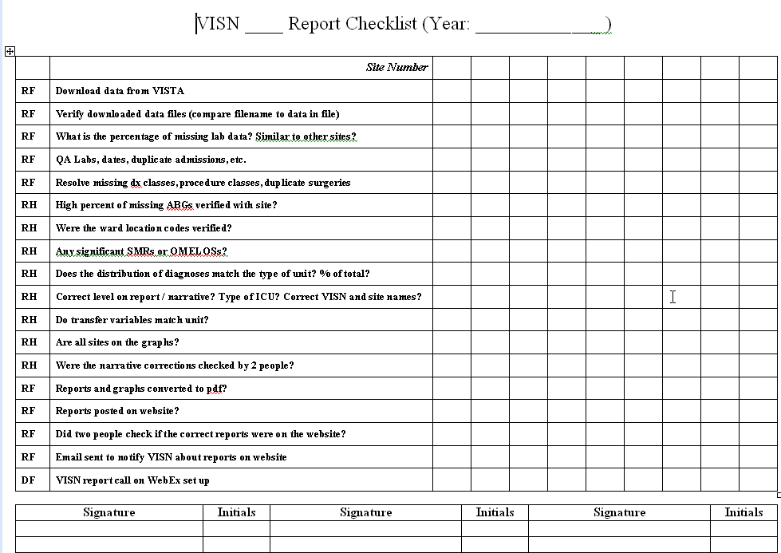

Figure B Funnel Chart

### Graphic depiction of confidence intervals as event rate increases, where each dot represents one VA ICUs results for a single 3 month period. Basis for setting a minimum event rate for reporting standardized mortality ratios. SMR = standardized mortality ratio, SD = Standard deviation.

